1. 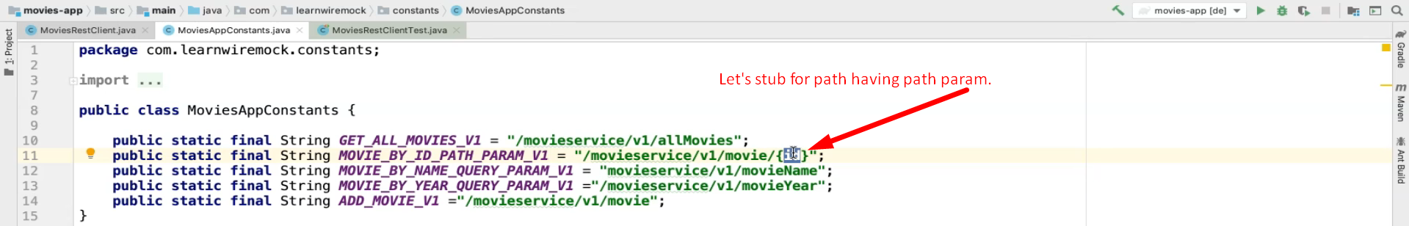
2. 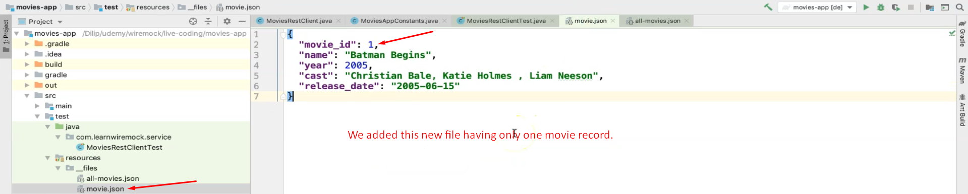  
   Making the request to WireMock.  
   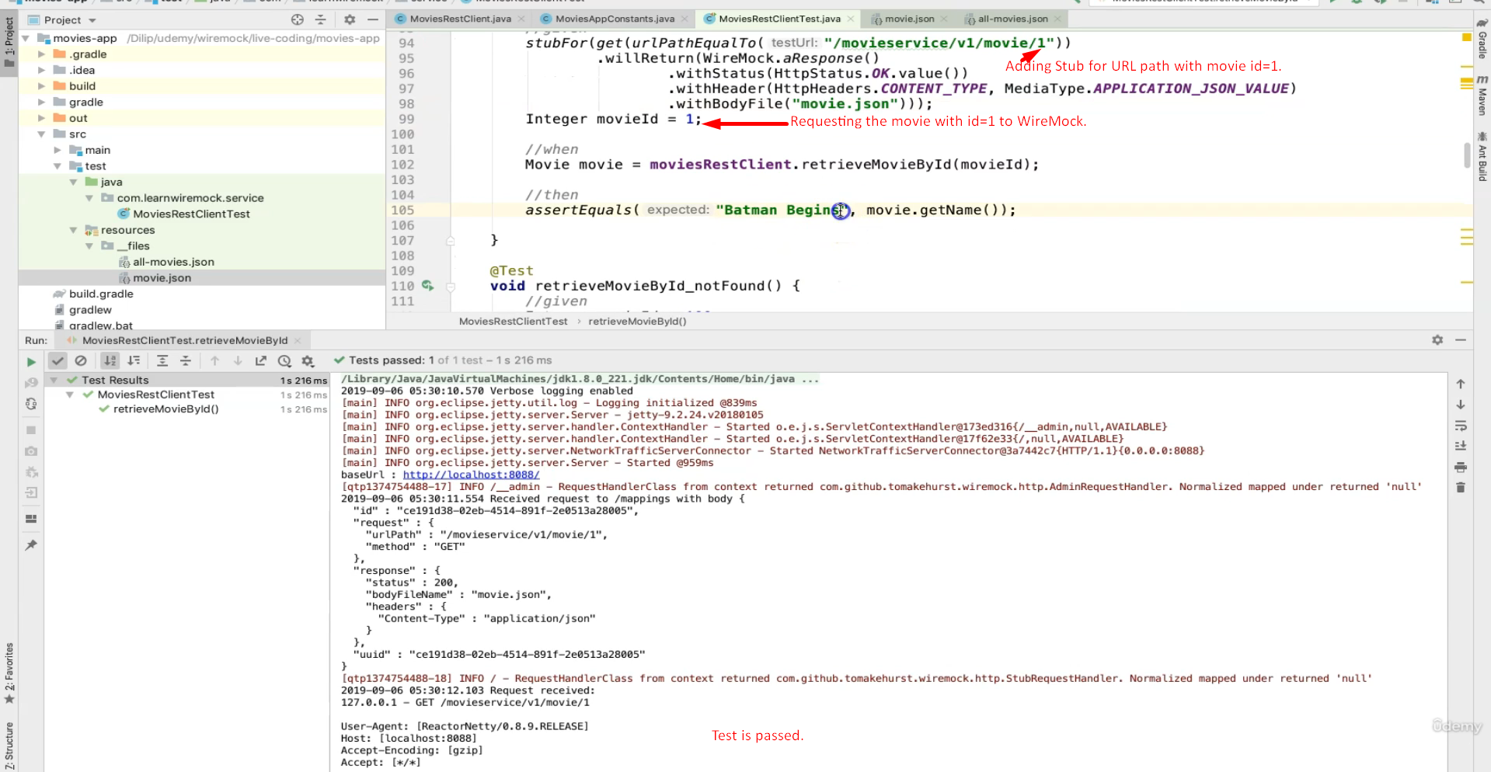
3. 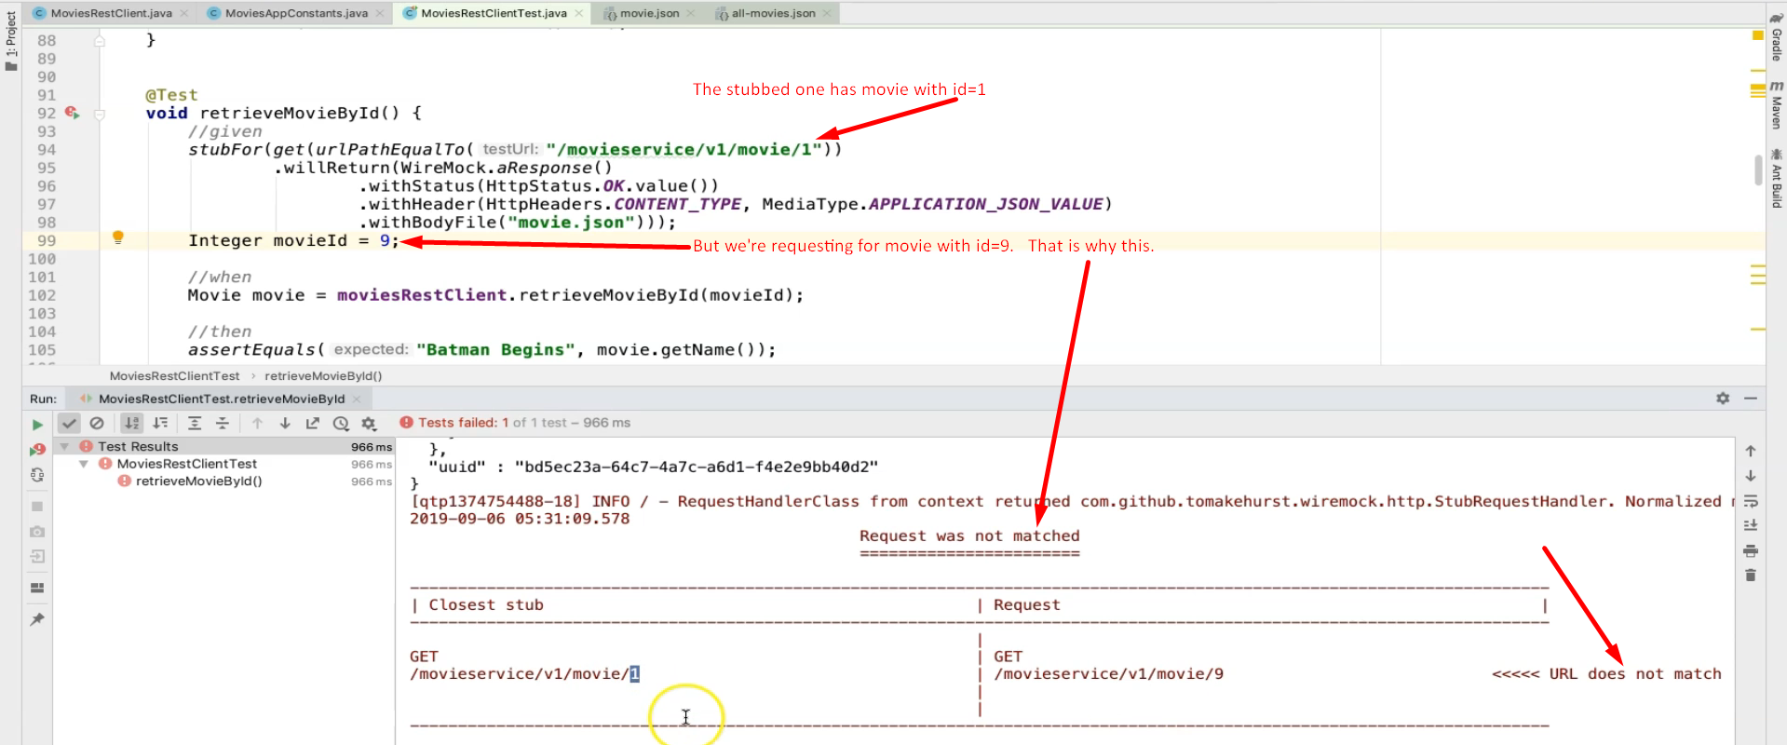
4. **Let’s make the stub more generic**.   
   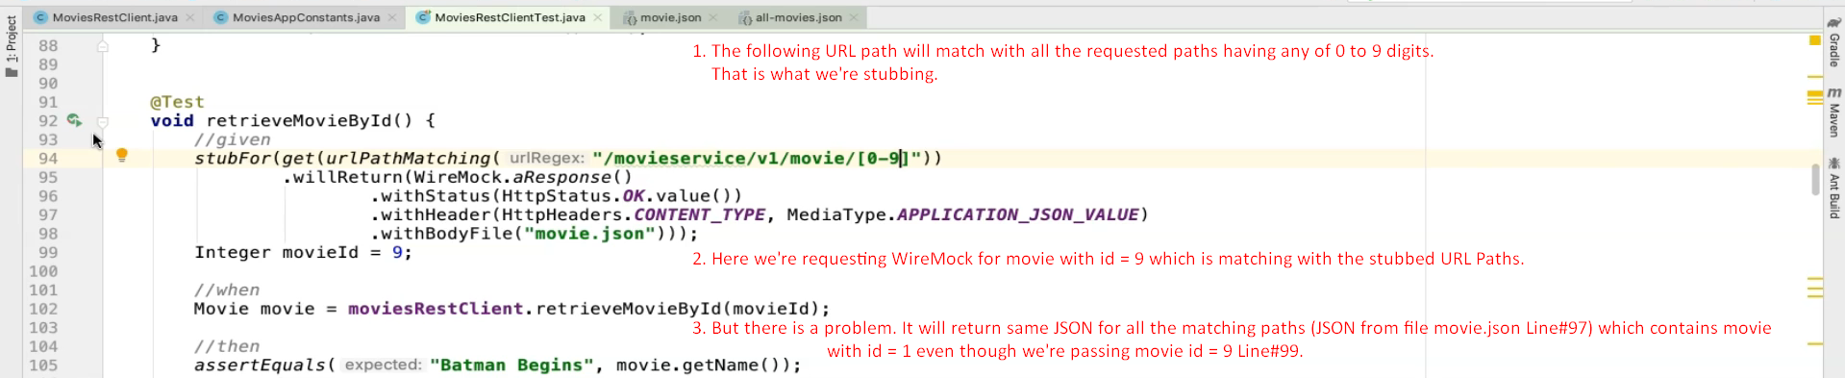  
   We will see the solution in next lecture.